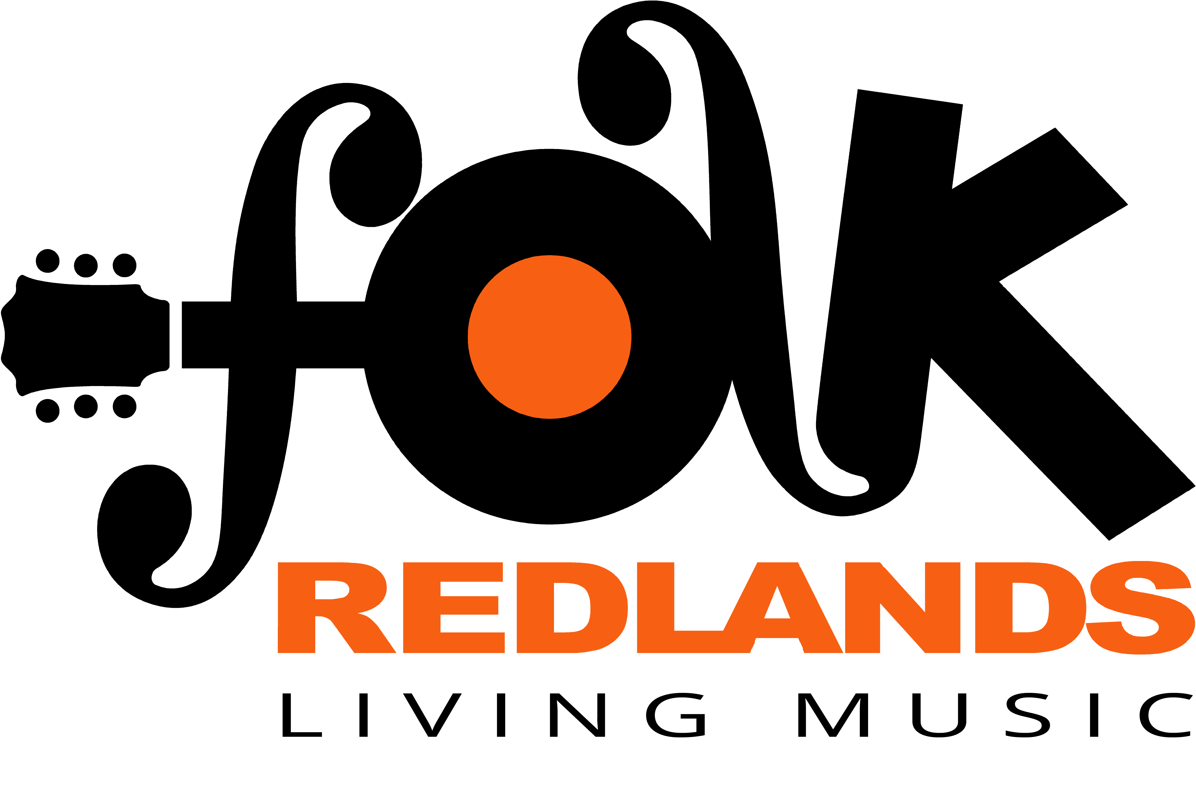
Folk Redlands Inc.
ABN 22 929 750675
PO Box 20, Cleveland Qld 4163
Email: folkredlands@yahoo.com

Application for Membership / Renewal Version: 5/8/2020

Complete this form to apply for membership or membership renewal with Folk Redlands Inc.

Date: dd/mm/yy
First Name: First Name Last name: Last name
Address: Address Line 1
Address Line 2 Post Code: Post Code
Email: Email Address Phone no. Phone No.

Signature of Applicant:

All new member Applications must be proposed and seconded by an existing member. If you have not arranged a Proposer and Seconder, leave this blank and committee members will complete this section.
Proposed By: Name Signature: Date: dd/mm/yy
Seconded By: Name Signature: Date: dd/mm/yy
Membership Fees cover membership until 30 June of each year.
For Members joining between April 1 – June 30, membership will be valid until June 30 of the following year. (Please select)
Single $ 5 ☐ Family $10 ☐

How did you hear about Folk Redlands?
Newspaper ☐ Website ☐ Facebook ☐ Word of Mouth ☐ Other ☐ (Please describe) describe
Would you be interested in volunteering to assist occasionally at Folk Redlands events? YES ☐ NO ☐

Payment options:
Cash: Pay by cash at a Folk Redlands Event
Cheque: Post cheque with completed form to address below.
Electronic transfer: to Bendigo Bank Account Name: Folk Redlands Inc BSB 633-000 Account No. 165 724 337
Please post or email the completed form after you have made the payment.
Postal Address: PO Box 20 Cleveland Qld 4163 Email: folkredlands@yahoo.com

Folk Redlands Inc. holds Public Liability insurance for $30 Million, any one occurrence.

Applications for membership will be considered by the committee and applicants will be advised accordingly.
Thank you for your interest.

Office Use Only
Secretary: | Application Approved: ☐ Denied ☐  Member list updated : date Applicant Advised: date
Treasurer: | Date Money Received/deposited: date
Publicity: | Subscriber list updated date

